**Test Issues Log: 8th Feb 2012**

Tested on: <http://182.50.141.145/applications/skillsepian_new/>

**On the “Browse Skills” and “Browse Jobs” pages:**

1. The following boxes are not adding any value and should be removed for now(we won’t worry about a Skill Category as there’s not enough skills. This can be re-implemented later – after this project, if necessary)(I am also removed this area, please check)

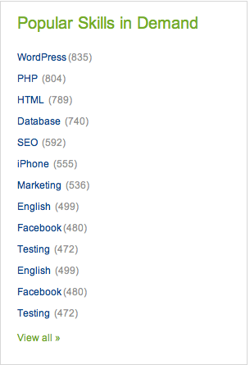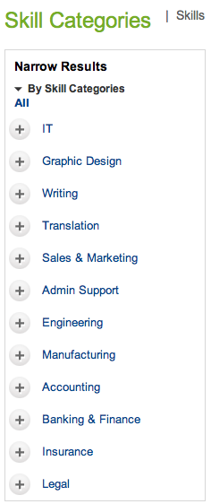

**On the View My Bids page:**

1. We have totally different formatting for the list grid to that of the Posted Jobs List on “View My Jobs List” page. Can we make it consistent:Done
   1. I prefer the header formatting of the Posted Jobs List (white font on light-blue); but would like a larger font size – so take the size of the Bids List font. Done
2. When a bid has just been entered, it is not yet successful. Therefore please do not update the “Bids Successful” field yet. Successful bids are completed bids – where it has been agreed and had led to an Interview. Done (After bidding page redirect to View my bid list.)
3. In the bids list section, please update the list title to “My Bids List” Done
4. The Header Row with the titles for each column should be fixed so as not to scroll – this makes it easier to read. Done
5. The Status column should be labelled “Bid Status”, and should display “Open” as a status for new bids. Done
6. To save space, the Negotiable column should have a drop-down with 2 options: “Yes/No”, instead of the current horizontal radio button which takes too much space. Done
7. This way, the date fields can stretch out a bit more so as not to hang over 2 lines Done
8. Up on the top of the page, next to Recruiter ID and to the right, the Recruiter User Name should be displayed as read-only. The preferred currency field can be pushed a bit more to the right. Done
9. I really liked the Displaying **1** to **2** (of **2** jobs) counter at the bottom of the View My Jobs List, this should also be implemented at the bottom of My Bids List. Done

**On the View My Job List page:**

1. Refer to point (2) regarding formatting of the list grid. The grid should also have scroll bars if it gets too large. Done
2. The “Number of Positions” field is redundant and should be removed. Done
3. The “Budget” field should be replaced with Min. and Max. Rate advertised on the job. Done
4. The fiel “File upload” should just be labelled “Uploads?” and the rows should display a file-clip icon (with URL link to the uploaded document).
5. The field “Job Start Date” needs to be displayed. As there’s not enough space horizontally, get rid of “Job End Date” instead. Done
6. The “Total Applied” field is redundant and should be removed. Done
7. The “Action” field should have the text links right-aligned. Done

**On the Update My Account page:**

1. The Profile Photo should not be displaying a file name, instead it should display the actual image, with a upload new image button below or next to it. Done
2. The location of the Profile Photo should not be at the bottom, instead all the fields should be moved slightly to the left and this photo field inserted to the right of the page, like it is on all other pages. Done

**On the My Messages page:**

1. The Recruiter ID is currently displayed in between the Actions menu and first row. This is incorrect. Instead the title at the top of the page should read: “Inbox for [Recruiter User Name]” Done
2. The columns do not have any header, there should be a header row that displays this, with same formatting and colour scheme as the column headers in other lists (i.e. white font on light-blue background) Done
3. Whenever the word “Credits” appear, it should always read “Skillsapien Credits”. Done